MedBuzz -IOT enabled medicine reminder

Mangesh Bahir
DOME
Vishwakarma Institute of Technology
Pune, India
mangesh.bahir22@vit.edu

Atharva Shinde
DOME
Vishwakarma Institute of Technology
Pune, India
atharva.shinde 22@vit.edu
Pranav Bedekar
DOME
Vishwakarma Institute of Technology
Pune, India
pranav.bedekar22@vit.edu

Sarthak Baviskar
DOME
Vishwakarma Institute of Technology
Pune, India
sarthak.baviskar22@vit.edu
Alok Dadhich
DOME
Vishwakarma Institute of Technology
Pune, India
alok.dadhich 22@vit.edu

Parkhi Vrinda Prasad
DOME
Vishwakarma Institute of Technology
Pune, India
vrinda.parkhi@vit.edu

Abstract— There are many problems faced by old age people and one of them is taking medicine on time. They usually forget to take the medicine and some old age people also have recollection issues due to medical problems such as dementia. This paper represents the idea consisting of a medical device we call “MedBuzz”, MedBuzz is a smart medicine device of solid medicines (such as pills and capsules…) and website (connected with the webserver) for its configuration and management. This prototype proposes the design and development of MedBuzz. It is a device that provides patients with medicines when they need them by alarming (i.e., buzzing) them and dispensing the required medicine.
Keywords—IOT, User Interface, ESP8266, Wireless, Automated.

Introduction
The aging population proposes many challenges which are unique and important to be addressed. These problems had to be taken into account for creating a prosperous environment in the medical industry. It is the need of the hour for these special problems to be solved. Also these solutions will ensure the management of complex medication regimens.
MedBzzz helps old age people to take the medicine on time and ensure a healthy well-being for the betterment of their future. It provides a user interface for the caretaker which helps in providing a personalized solution for everyone.
If we talk about medication types then till date only solid medicinal pills could be used in our MedBuzz, but in future there may be a scope of building a mechanism based on liquid-based medicines which will provide a more complete solution towards this issue.
The use of Node-MCU plays a vital role in terms of making this application successful as it provides connectivity with the online word. It also plays a important role in making this application personalized by making sure that every input and output only gets to the registered user/the registered caretaker. Provided with a 5V battery the Micro-Controller Unit has red led’s and the buzzer which helps indicate the exact time and exact box from where medicine has to be taken.
A 5V power supply is used to power the system.Buzzer is used to alert the patient to take medication in time. It ensures that medicine is taken on the precise time decided by the care take itself. Also, it alerts the patient about the medicine time in any circumstances for instance if a patient is another room the buzzer does an excellent job to remind the patient about the time medicine had to be taken.
A Web Application is there for caretakers to monitor the patient’s medical routine. With proper password and access to the account of caretaker he could even make changes to the timings of the medication which provides a simple user interface through which anyone with the proper access can alter the course of medication.
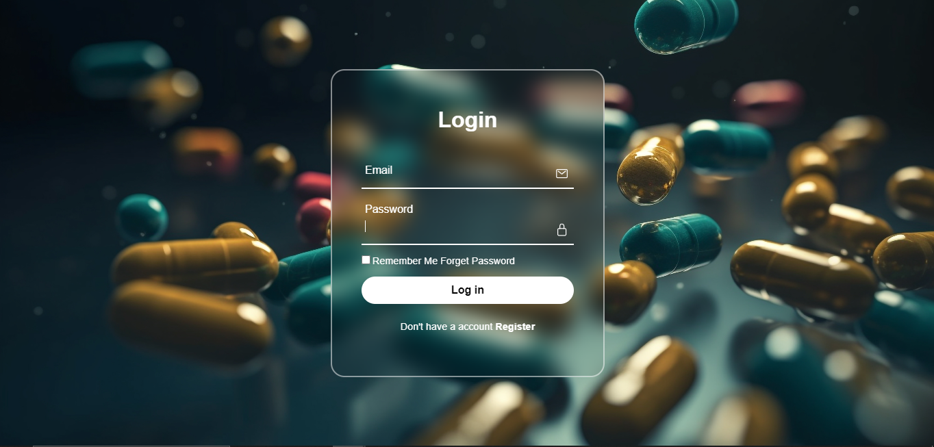
Figure 1.1. User Interface (Login page)

This device is one of the best possible options to reduce medication error using a simple microcontroller setup. MedBuzz contains medicine tablets (solid medicine) in each tray that enables us to differentiate according to different times of the medication that must be taken.

LITERATURE REVIEW
In the work by Rita Barsum and Gizelle Racho [1], a wireless device was manufactured with the use of a Arduino MKR NB 1500 in order to achieve wireless connection for creating a dosage system with minimum human effort and maximum efficiency during medication.
Subiksha K et al [2], work on designing a medicine dispenser for corona patients keeping social distancing in mind. Dispenser machines can dispense different items or quantities of something much more conveniently. It is similar to an automated machine without man power which we normally see in metropolitan cities. This work was done during Covid-19 pandemic.
Mr. Manjunatha. Y. R et al [3], they created a Alarm System that is incorporated to provide two types of indications one by LED light indication and the other by providing a buzzer sound. The user is required to consume the pills and press the reset button to bring back the container position near the funnel and there is an alarm to check for the tablets in the pill container and to inform the caretaker to fill the dispensing container with pills.
S. Jayanthi et al [4], their work presents a smart medicine dispenser prototype. The main purpose of the system is to help the patients, primarily seniors, take their medicines on time in an easy way without any possibility of missing pills, also reducing the risk of over or under dosage accidentally. Not taking medicines correctly can have a serious consequence such as delayed recovery, illness and even death. Their work inspired us to create our own device to solve the problem.
Sachin Kansal et al [5], proposes the design and development of the Medicine Dispenser in a real-time scenario. s a device that provides patients with medicines when they need them by alarming them and dispensing the required medicine.
Gleiston GUERRERO-ULLOA et al [6], their work consist of a smart medicine dispenser of solid medications (pills, capsules,. . . ) and a mobile application for its configuration and management. The main idea is to offer a solution to help people (especially vulnerable ones) to avoid incorrect medication intakes.
Gregory Cu et al [7], they developed a smart pill box that tries to improve medication adherence. The pill box automatically dispenses medicine on a set time based on the input schedule in the mobile application and has an LED and buzzer to indicate that medication is due. An IR sensor detects whether the medication has been taken out of the pill box and logs the time it was taken.

HRDWARE DESCRIPTIONS
NodeMCU ESP8266: - The NodeMCU ESP8266 is a versatile and popular microcontroller board used for Internet of Things (IoT) and embedded projects. It's based on the ESP8266 Wi-Fi module, and it's known for its compact size, low cost, and ease of use.
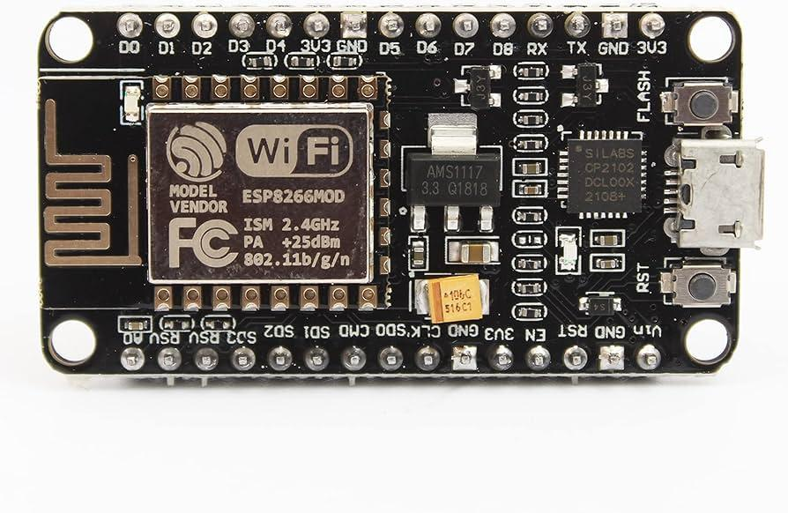
Figure 3.1. NodeMCU ESP8266.

- Connectivity: -The built-in Wi-Fi capability allows NodeMCU to connect to wireless networks, making it perfect for IoT applications. It can communicate with other devices over the internet or within a local network, enabling remote monitoring and control.
- Development Environment: -NodeMCU is well-supported by the Arduino IDE and Platform IO, making it accessible to both beginners and experienced developers. The NodeMCU firmware can be easily flashed to the device using a USB connection.
- Programming: -NodeMCU can be programmed using the Arduino IDE, Lua scripting language, or other popular languages. The ESP8266 community provides extensive libraries and resources for easy development. It supports a wide range of sensors, displays, and peripherals, making it suitable for various applications.
Power Supplies: - A 5V power supply is used in our device. The small size of the power supply ensures that the device could be travel friendly it also fits in its place perfectly without disturbing other components. Therefore, 5V power supply is best suited to fit into our device.

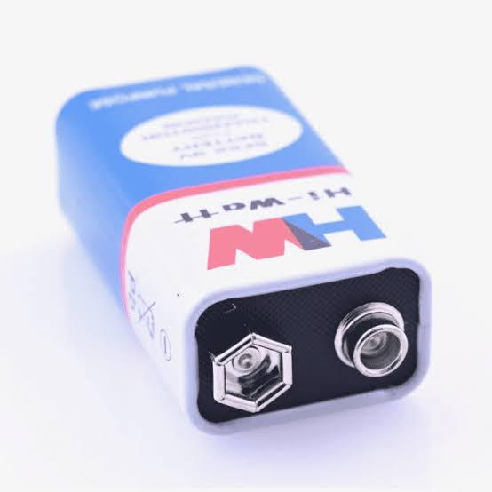

Figure 3.2. 5V Battery.
Led:- Light Emitting Diodes, commonly known as LEDs, are semiconductor devices that emit light when an electric current passes through them. They have become a ubiquitous and energy-efficient source of lighting in various applications.

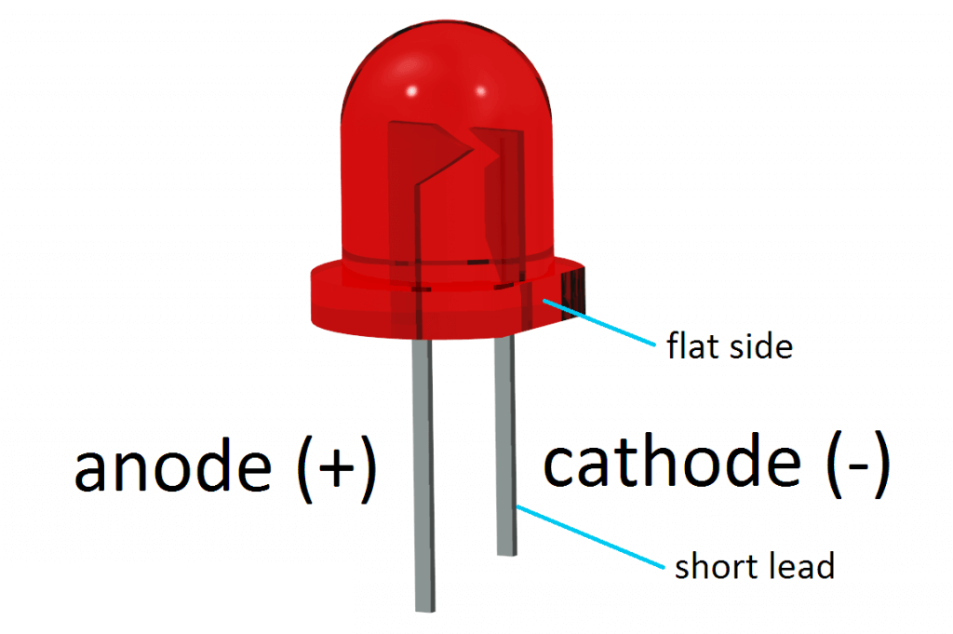

Figure 3.3. Red LED.
- Operation: LEDs operate based on electroluminescence. When a voltage is applied across the diode, electrons and holes recombine, releasing energy in the form of photons, which produces visible light. The color of the light depends on the materials used in the LED.
- Efficiency and Energy-Efficiency: LEDs are highly efficient light sources. They convert a large portion of the electrical energy into visible light, making them far more energy-efficient than traditional incandescent or fluorescent lights. This efficiency results in lower energy consumption and longer lifespans.
- Longevity: LEDs are known for their long lifespan. When operated within their recommended parameters, LEDs can last tens of thousands of hours. This longevity makes them cost-effective in the long run, even though they might have a higher upfront cost compared to traditional lighting.
- Color: Specifically red LED is chosen for this device as our eyes are more sensitive to red light than to other colors, and red light is more easily detected in low-light conditions. This makes red LEDs stand out and catch our attention, especially in dark or dimly lit environments.
Buzzer: -A buzzer is an electroacoustic transducer that converts electrical signals into audible sound. In the context of breadboard projects, buzzers are often used to provide audio feedback or alerts, making them an essential component for various applications.
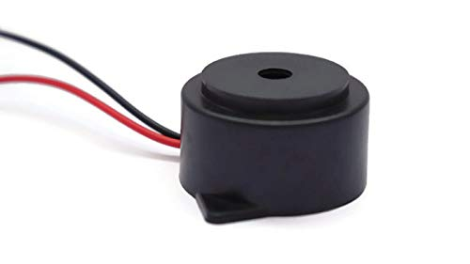

Figure 3.4. Buzzer.

Moreover, we also have jumper wires to make all connections according to requirement. They play a crucial role in our device by facilitating the creation of temporary electrical connections between different components, ensuring signal transmission and data flow. We have use Male to Male Wires (M-M) These have pins or connectors on both ends and are commonly used to bridge gaps on a breadboard or to connect components with compatible female connectors.

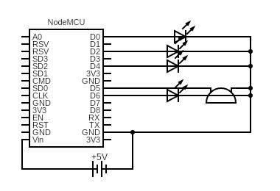
Figure 3.5 Circuit diagram

SOFTWARE DESCRIPTIONS
The software used to develop the system primarily uses the Arduino IDE, The Arduino IDE is an open-source software platform developed to provide a user-friendly environment for programming and developing applications for Arduino microcontroller boards. It simplifies the process of writing, compiling, and uploading code to these boards, making it accessible to both beginners and experienced developers. Moreover, Arduino IDE is open Source, it has Cross-Platform Compatibility, offers a vast collection of libraries, and provides a simple user interface.

Talking about libraries, we have mainly used libraries according to necessity and shown as below.

- Time.h:- The Time.h library in Arduino is used for timekeeping and manipulation. It provides functions to work with time in various formats and can be used to set and retrieve the current time, create timestamps, and schedule events.

- TimeAlarms.h: - This is an Arduino library that builds upon the Time library. It allows you to set and manage alarms and timers. This is useful for scheduling specific actions or events at predefined times, making it valuable in applications where time-based actions are critical.

- NTPClient.h: - This library enables Arduino devices to synchronize their internal clocks with Network Time Protocol (NTP) servers over the internet. This is crucial for keeping accurate time on IoT devices and ensuring they have the correct time and date information.

- WiFi.h: The WiFi.h library is used for configuring and managing Wi-Fi connectivity on Arduino-based projects. It allows Arduino devices to connect to Wi-Fi networks, making them capable of internet access and communication with other devices or servers.

- ESPWebServer.h: - Thai is a library that is commonly used with ESP8266 and ESP32-based Arduino boards. It simplifies the creation of web servers on these devices, enabling users to serve web pages, host web-based interfaces, and handle HTTP requests. This is valuable for building IoT applications with a web-based user interface.

These libraries are essential for compiling and running every line of our code. This code consists of following parameters which are briefly explained below: -
- Global Variables and Constants: ssid and password: These parameters are utilized for connecting to a specified Wi-Fi network. The code defines GPIO pin assignments for LEDs and a buzzer. Several global variables are employed to maintain alarm settings, selected LEDs, and whether an alarm has been activated.

- setup() Function: Serial communication is initialized for debugging purposes. The code connects to the designated Wi-Fi network. An NTP client is set up to synchronize the device's time with a remote NTP server. GPIO pins for LEDs and the buzzer are configured. Routes for the web server (e.g., / and /setAlarm) are established, and the server is started.

- loop() Function: This function handles incoming HTTP requests via the web server. It keeps the device's time synchronized through NTP updates. Additionally, the function introduces a 1-second delay (1000 milliseconds) using ‘Alarm.delay()’ to facilitate time-based alarm triggering.

- Web Server Functions: handleRoot(): This function serves an HTML page featuring a form for configuring alarms and selecting LEDs. getIndexHTML(): It generates the HTML content for the form. handleSetAlarm(): Responsible for processing form submissions, it extracts the chosen alarm time and selected LEDs to illuminate. The collected information is stored in global variables.

- checkAlarm() Function: This function checks if the current time aligns with the set alarm time and ensures that the alarm hasn't been triggered yet. If the specified conditions are met, it triggers the activateAlarm() function.

- activateAlarm() Function: When the alarm is activated, this function comes into play. It illuminates the selected LEDs and triggers a buzzer, creating both visual and auditory alarm effects. The LEDs and buzzer cycle on and off in intervals of 500 milliseconds. The alarm activation status is tracked to prevent repetitive activation.

In summary, this code provides a user-friendly platform for configuring alarms through a web interface and initiating visual (LED) and auditory (buzzer) alerts when alarm times are reached. It demonstrates the integration of IoT technology for improved medication management and is adaptable for various applications.

WORKING MODEL

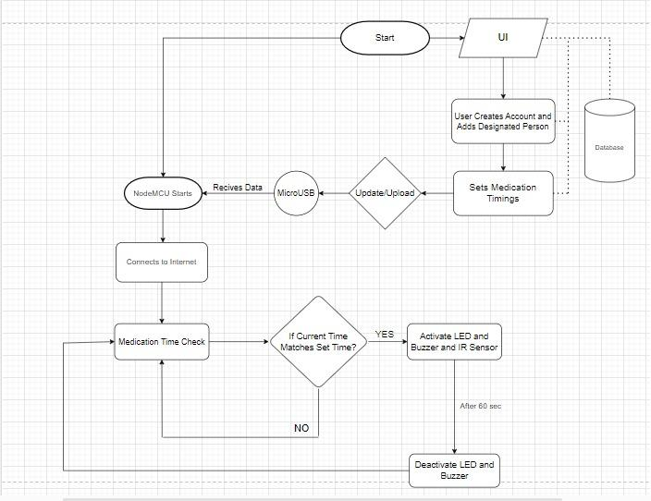

Figure 5.1. Flow Chart

The above flowchart Fig 5.1 explains the complete workflow of the system. Starting from the User Interface the time of the medication are set by the care taker according to the medicine prescribed by the respectively doctor or medical in charge then the data is stored inside the database.

The code sets up a webserver which is displayed whenever the user logs in to his account and is redirected to the ip of the specific ESP webserver. The user then inputs his/her alarm timings for simplicity the user currently gets only 3 options corresponding to Morning, Afternoon and night timings for meds this helps in reducing code complexity but limits the ability to test the code though a unit test by hard coding a timing is possible and is carried out after this the user selects the appropriate med slots/leds to blink at the time of the alarm. In the background the webserver sends this data to the esp8266 module using its internet connectivity established using Wi-Fi. The ESP reads the LEDS to blink using HTML id “Led1”, “Led2” etc.

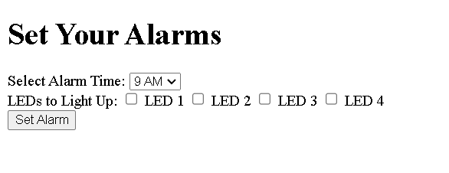
Image 5.1. Time Set
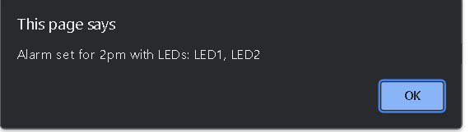
Image 5.2 Alert after setting an Alarm

The ESP reads the Alarm timing using the server.hasarg function in the ESP webserver library. Then the system checks every 60 seconds if the alarm timings given by the user match the current time, if yes the buzzer goes off with the specified leds else nothing happens (as shown in Image 5.1). ESP matches the current time using something called NTP (Network Time Protocol) which is a protocol used to synk various devices across the internet. For this the ESP must establish a UDP (User Datagram Protocol) Communication with a regional NTP server using a link specified in the code and also as explained in Fig 5.2.

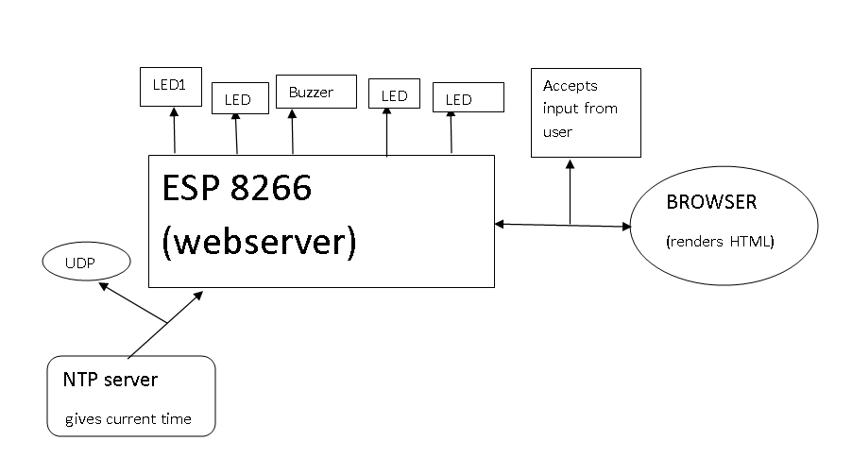

Figure 5.3. System Block Diagram

On the hardware side the system comprises of minimalist hardware which includes a esp8266 module, 4 leds and a buzzer , this is the core hardware with electronic components besides this the product also requires a box of special features to hide the electronics inside. The leds are connected to 4 GPIO(general-purpose input/output) pins and buzzer to the fifth which are declared as output pins in the code.
Thes 4 leds and the buzzer work according to the provided data from the NPT server which then helps to indicate the exact timing of when the medication is to be taken on proper time which is the whole idea of our device.
Completed with all the parts combined, our device helps ensure that every medicine is taken on time without any delay caused due to any condition. Moreover, the health of the patient remains well. The final prototype of our looks as Image. 5.2.
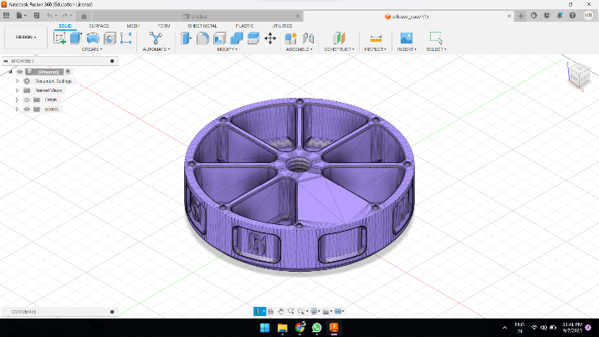
Image 5.4. Final Prototype

RESULT AND DISCUSSION
We conducted a survey to gauge the need of such a product in today’s market among the elderly following were the results:
We collected the data of only those people who actually take some kind of medication as they were the only ones relevant in the study:
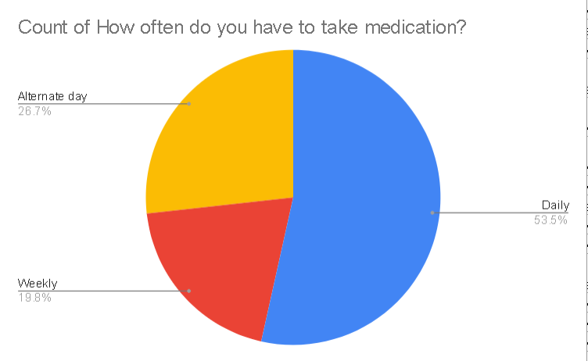

Figure 6.1. Pie chart 1

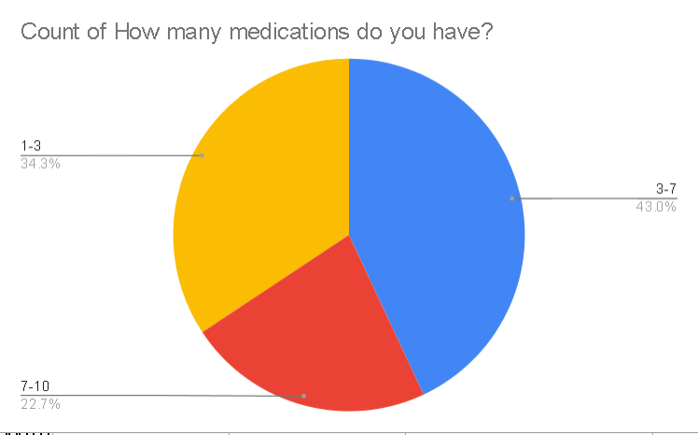
Figure 6.2. Pie chart 2

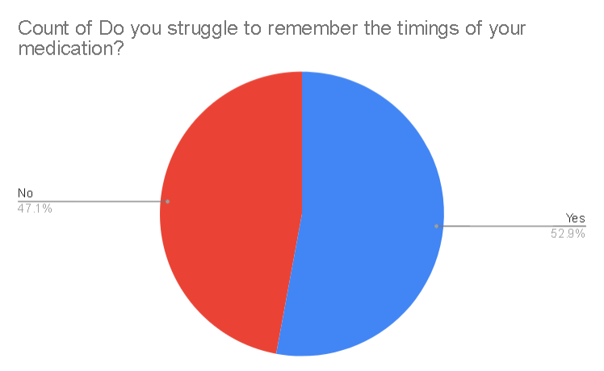

Figure 6.3 Pie chart 3

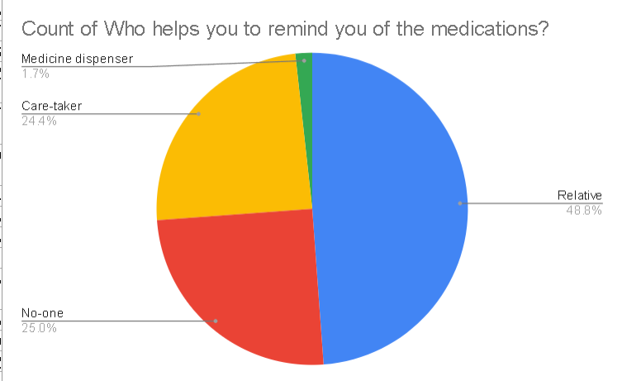

Figure 6.4 Pie chart 4

This result highlights the limited use of medicine dispensers as device to use for medicine reminder. This shows how the demography despite struggling to remember their timings as shown in previous result have no technological assistance but have to rely on other inndividuals.

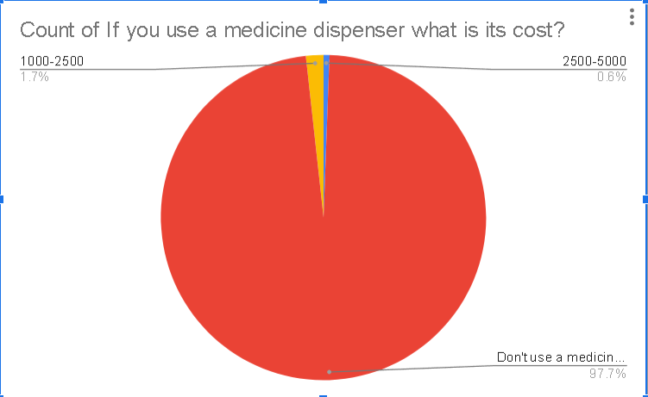

Figure 6.5 Pie chart 5

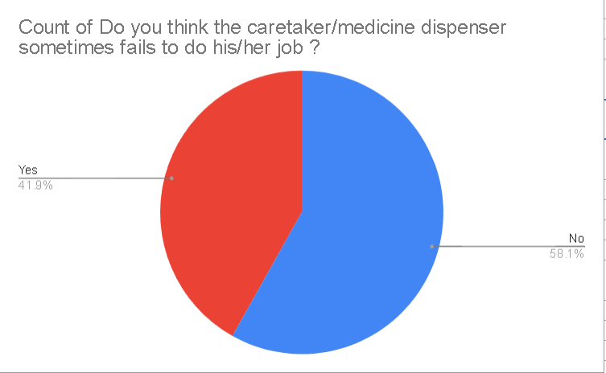
Figure 6.6 Pie chart 6

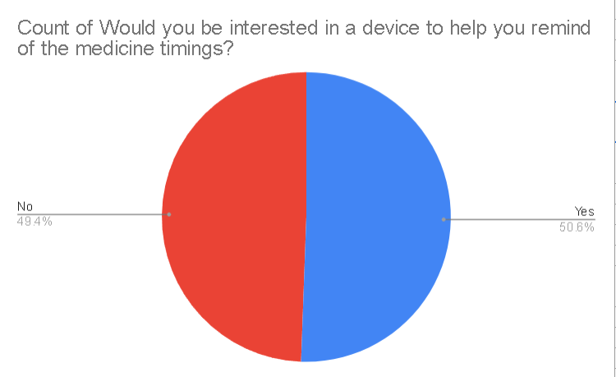
Figure 6.7 Pie chart 7

But there are some limitations in our work. One of them is that we can only store four types of pills in our device. Another is that only a limited number of pills can be stored in each container.

The project showcased the potential for real-time monitoring, remote access, and automated alerts, enabling caregivers and healthcare providers to stay informed about medication adherence and respond promptly to any deviations. The user interface designed with the elderly in mind ensures that the device is easy to operate, even for those with limited technical familiarity. Moreover, the project highlights the importance of user-centric design in IoT healthcare solutions.

Currently the UI of selecting the alarms is pretty simple and not very attractive to make the changes in the ui we have to find ways to make the web code more concise and understandable and doesn’t add complexity to the ESP code. For this we have to implement a OTA ( Over The Air ) programming of the ESP through which we can update the ESP code wirelessly, also for testing purposes we have we have hard coded the credentials of Wi-Fi ssid and password into the ESP code, to make this user friendly we have to implement a library called WIFI manager which will enable the user to connect the ESP to nearest available network.

CONCLUSION
In conclusion, the development of an IoT-based medical dispenser tailored for the elderly population represents a significant step towards addressing the healthcare needs of our aging society. This research and project have demonstrated the feasibility of creating a smart, user-friendly device that can help older adults manage their medication regimens more effectively and independently. By seamlessly integrating IoT technology with medication management, we have improved medication adherence, reduced the risk of dosage errors, and enhanced the overall quality of life for seniors.

Additionally, ensuring data security and privacy is a critical aspect that requires continuous attention and development.

In the broader context, the success of this IoT medical dispenser project underscores the potential of IoT technologies to transform healthcare delivery, enhance patient outcomes, and alleviate the burden on healthcare systems, especially in the context of an aging population. It represents a promising step forward in the ongoing efforts to provide comprehensive, patient-centered care.

As we look ahead, the collaborative efforts of researchers, engineers, healthcare professionals, and policymakers will be crucial in realizing the full potential of IoT in healthcare, and, in improving the well-being of older adults. With ongoing dedication and innovation, we can continue to refine and expand the applications of IoT in the field of geriatric care, making a positive impact on the lives of seniors worldwide.

References
[1] Subiksha K, Rajeshwar A, Mohamed Shahul Hameedh, Mrs. Manimekalai V “Automated Medicine Dispenser using IoT Technology”(IRJET).
[2] Nanda Kishor Panda, Shubham Bhardwaj , H.Bharadwaj, Rohil Singhvi “IOT based Advanced Medicine Dispenser Integrated with an Interactive Web Application” (IJET).
[3] Hanne H. Kleiven1, Birgitte Ljunggren1 and Marit Solbjør “Health professionals, experiences with the implementation of a digital medication dispenser in home care services – a qualitative study” (.BMC Health Services Research).
[4] Mr. Manjunatha. shY. R, Bhavana. R, N. Lohith, Bindushree. S. V “MEDIC-The Smart Medicine Dispenser” (insc.in).
[5] S. Jayanthi, S. Sindhuja, Sariga. S, Hemamalini. A, Pavithra. G, Rathi Priya. M “SMART PILL DISPENSER” (Journal of Critical Reviews).
[6] Sachin Kansal, Vipul Goel, Daleep Singh, Arjun, Vibhav Sharma, Mayank Auddy “MedAtBed: Design and Development of the Medicine Dispenser”(Research Square).
[7] Gleiston GUERRERO-ULLOA, Miguel J. HORNOS, Carlos RODR´IGUEZ-DOM´INGUEZ and Ma. Mercedes FERNANDEZ-COELLO “IoT-Based Smart Medicine Dispenser to Control and Supervise Medication Intake” (IOS Press).
[8] Jyothis Philip, Feba Mary Abraham, Ken Kurian Giboy, B J Feslina and Teena Rajan “Automatic Medicine Dispenser using IoT” (IJERT).
[9] Gregory Cu, Dominic Chan, Angelo Gabriel Chua and Emmanuel Gabriel Ramin “A Smart Medicine Pill Box for Improving Medication Adherence”(DLSU Research Congress 2021)
[10] Zara Nasir , Amina Asif , Muhammad Nawaz and Muhammad Ali “Design of a Smart Medical Box for Automatic Pill Dispensing and Health Monitoring” (MDPI).
[11] Mrityunjaya D H, Kartik J Uttarkar, Teja B, Kotresh Hiremath “Automatic Pill Dispenser” (IJARCCE).
[12] Aditya Patil, Darshan B.G, Dr. D.V. Ashoka, Nethravathi B “IoT Based Medicine Dispenser ”(IJERT).

